Optical, Thermal And Spectral Properties Of Rubidium Sulphate Doped L–ALANINE HYDROGEN CHLORIDE .
Dr. P.GIRIJA,
ASSISTANT PROFESSOR,
DEPARTMENT OF CHEMISTRY, ANNAMALAI UNIVERSITY, CHIDAMBARAM, TAMIL NADU, INDIA.

Dr.P.Girija,

Department of Chemistry, Arignar Anna Government Arts College, Villupuram - 605602, India.
L-Alaninerubidiumsulphatecrystals are synthesized by adding L-Alaninehydrogenchloride monohydrate and rubidiumsulphate in equimolar concentration (1:1ratio) by slow evaporation solution growth technique (SEST). Further the so formed L-Alaninerubidiumsulphatecrystals is characterized by the following techniques like Single crystal x-ray diffraction, Fourier Transform Infrared spectroscopy (FTIR), Scanning Electron Microscopy - Energy dispersive Spectroscopy (SEM-EDS), Second Harmonic Generation (SHG), UV-Visible NIR Spectroscopy, Powder X-ray DIFFRACTION AND Thermogravimetricanalysis. The single crystal XRD reveals that there is a slight modification in the cell parameter values of L-Alaninerubidiumsulphate crystals with change alpha, beta, gamma =90 degree and it's space group being P212121. In powder XRD spectrum the reduction in intensity of peaks and shift in difraction peaks occurred for L-Alaninerubidiumsulphatecrystals. Transparency of the new crystal can be confirmed by UV-Visible spectroscopy and it's band gap energy is calculated to be higher inducing an optical property to it. The presence of functional groups are confirmed by Fourier transform infrared spectroscopy. High nonlinear efficiency of the grown crystal is proved by second harmonic generation(SHG). The melting point and withstanding capacity of newly grown crystal is confirmed by thermogravimetric analysis. The surface morphology of newly grown crystal L-Alaninerubidiumsulphate is observed from scanning electron microscopy and presence of rubidium metal is confirmed by energy dispersive spectroscopy.
Keywords: Slow evaporation solution growth technique, FTIR, Rubidium Sulphate, Transparency, Bandgap energy.
Corresponding author : gk_au09@yahoo.com,
Dr. P. GIRIJA, ASSISTANT PROFESSOR, DEPARTMENT OF CHEMISTRY, ANNAMALAI UNIVERSITY, CHIDAMBARAM, TAMIL NADU, INDIA.

Dr.P.Girija, Department of Chemistry, Arignar Anna Government Arts College, Villupuram - 605602, India.
INTRODUCTION
Most of the amino acids and their complexes belong to the family of organic and semi-organic nonlinear optical (NLO) materials that have potential applications in second harmonic generation (SHG), optical storage, optical communication, photonics, electro-optic modulation, optical parametric amplification, optical image processing, etc. [1], [2], [3], [4], [5], [6]. Amino acid family crystals have over the years been subjected to extensive investigation by several researchers for their nonlinear optical properties [7], [8], [9], [10]. Among the amino acids, l-alanine is the simplest acentric crystal with a second harmonic generation (SHG) efficiency of about one-third of that of the well known KDP and it is a naturally occurring chiral amino acid with a non-reactive hydrophobic methyl group (CH₃) as a side chain [11], [12], [13]. The l-alanine molecule exists as a zwitterion, where the carboxyl group dissociates and the amino group protonates. Some complexes of l-alanine have been recently crystallized and various studies have been investigated by many researchers [14], [15], [16], [17], [18]. The crystal structure of l-alanine hydrogen chloride (LAHC) monohydrate was solved by Yameda et al. [19] and was observed to be orthorhombic; its molecular formula is (C₃H₈NO₂Cl·H₂O). The NLO activity of the undoped LAHC has been reported by our group for the first time [20]. Various dopants influence the properties of the crystals like growth kinetics, surface morphology, optical, electrical and mechanical properties, etc. The dopant effect depends on the solubility of the host and the impurity phase, concentration of the dopant, temperature and pH of the solution [21,22]. It has been reported in the literature that doping NLO crystals with various dopants can alter physical and chemical properties and doped-NLO crystals find wide applications in opto-electronic devices compared toundoped NLO crystals. Doping of an NLO material like a KDP crystal with an alkali halide like KCl improves the growth rate, and optical and dielectric properties. Keeping this in mind, an attempt has been made in this work to introduce rubidium Sulphate (RbSO₄) into the lattice of the LAHC crystal to alter its various properties. The aim of this paper is to report solubility and growth and powder and single crystal X-ray diffraction studies, UV–visible transmittance studies, SHG, chemical analysis, Thermal studies, FTIR AND SEM-EDS of Rubidium sulphatedoped LAHC crystals.
METHODS AND MATERIALS
Synthesis and crystal growth
The transparent bulkiest single crystal of L-Alanine rubidium sulphate crystal is a synthesized by doping rubidium sulphate (Sigma Aldrich) and L-Alanine hydrogen monochloride(Merck).These two substances are mixed in the ratio 1:1 and dissolved in triply distilled water at room temperature with continuous and constant stirring for about 3 to 4 hours in the conical flask using magnetic stirrer. The contents in the conical flask is filtering using whattmann filter paper after 3 to 4 hours and the filtrate is collected in the beaker and covered with rubber band polythene sheet with tiny holes on the polythene sheet for the evaporation to take place. After two to three weeks seed crystals are formed at the bottom of the beaker (450 ml) and then its growth takes place after few days a bulkiest single crystals of L-Alanine rubidium sulphate is called and photographed whose figure 1 is shown as follows.

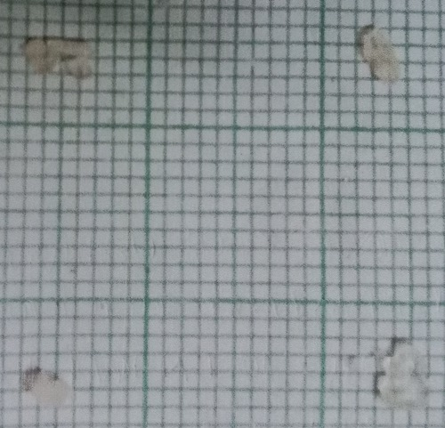
Fig. 1 Images of L-ALANINERUBIDIUMSULPHATE crystal

SCANNING ELECTRON MICROSCOPE WITH ENERGY DISPERSIVE SPECTROSCOPY (SEM-EDS):-

Surface morphologies of the samples are observed by using JEOL JSM 5610LV scanning electron microscope (SEM), EDS, a chemical microanalysis technique with cobalt as a standard, is performed in conjunction with resolution 3.0 nm, accelerating voltage 20 KV and maximum magnification 3,00,000 times. The investigation of influence of rubidium (Rb) doping on the surface morphology of L-Alanine faces reveals the formation of structure defectcentred. The incorporation of rubidium (Rb) in the crystalline matrix results in more scatter centres than the pure L-Alanine which is shown in the figure 2 as follows.
EDS Analysis: This analysis is an analytical tool used to screen the chemical compositions of different elements in a solid sample and to determine the relative abundance of such chemical elements. The existence of rubidium (Rb) is confirmed from the EDS spectrum which is shown in the figure 3, without any doubt , moreover the presence of carbon, oxygen and sulphate also is shown in the grown crystals which can be found from the figure 3.
Figure-2- SEM Image of L-Alanine rubidium sulphate crystals,

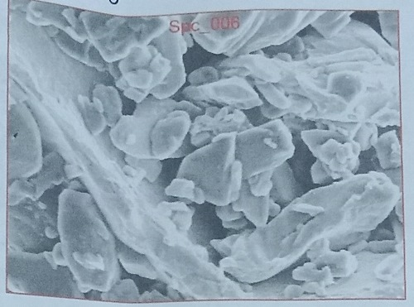
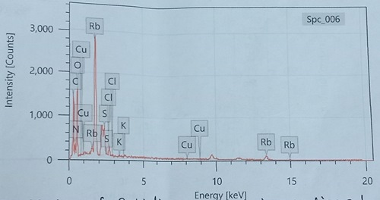
Figure 3 EDS graph of L-Alanine rubidium sulphate crystals,

SINGLE CRYSTAL XRD ANALYSIS:
The Single crystal X-ray diffraction analysis is done by Bruker AXS (Kappa Apex II) X-ray diffractometer. Hence the unitcell values are determined along withstructuralalignment if necessary.The table 1 shows the unit cell values of both L-Alanine and L-Alanine rubidium sulphate crystals.
Table -1-cell parameters values of L-Alanine and doped L-Alanine rubidium sulphate crystals,
Lattice ParameterValues | a_{A}⁰ | b_{A}⁰ | c_{A}⁰ | v _{A}³⁰ | System
L-Alanine | 6.038 | 12.317 | 5.804 | 430.93 | Orthorhombic
L-Alanine Rubidium Sulphate | 5.786 | 6.043 | 12.367 | 432 | Orthorhombic

Whose angles for doped L-Alanine rubidium sulphate crystals α=β=γ=90˚.
In the above table,the cell parameter values is a=6.028A˚, b=12.317A˚,
c=5.804A˚ and v=430.93A˚³ with orthorhombic system for pure L-Alanine
crystals.Thecell parameter values are slightly modified due to the change
in occupational sites of the metal rubidium on the L-Alanine
matrix, therefore their values are a=5.786A˚, b=6.043A˚, c=12.367A˚ and
v=432A³˚ with change in system or space group as Orthorhombic which
form a new mixed crystal. Figure 4-a,b,c shows the structure and cell
parameter values of so formed L-ALANINE Crystals.

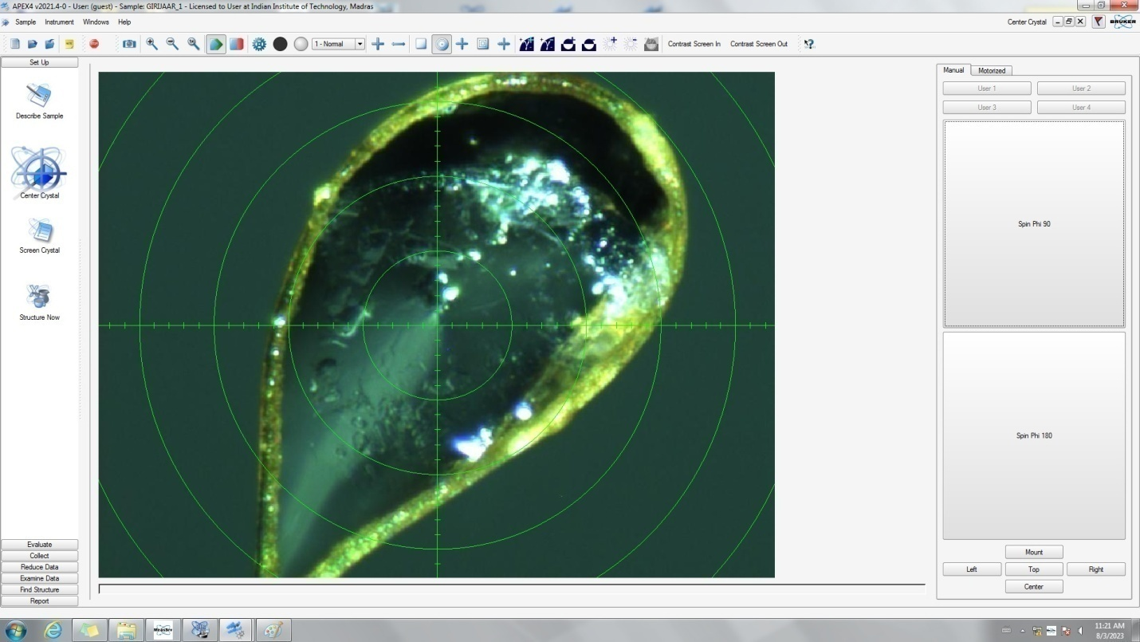

Figure 4 a Structure of L-Alanine rubidium sulphate crystals,

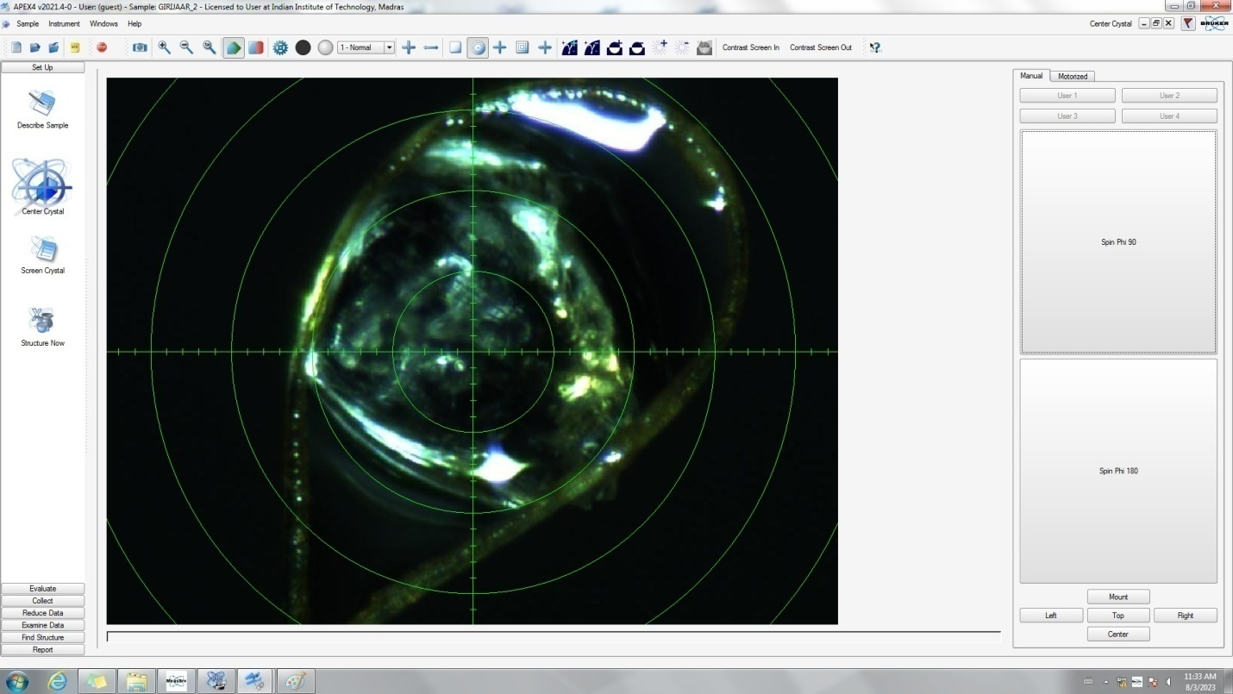

Figure 4, b Structure of L-Alanine rubidium sulphate crystals,
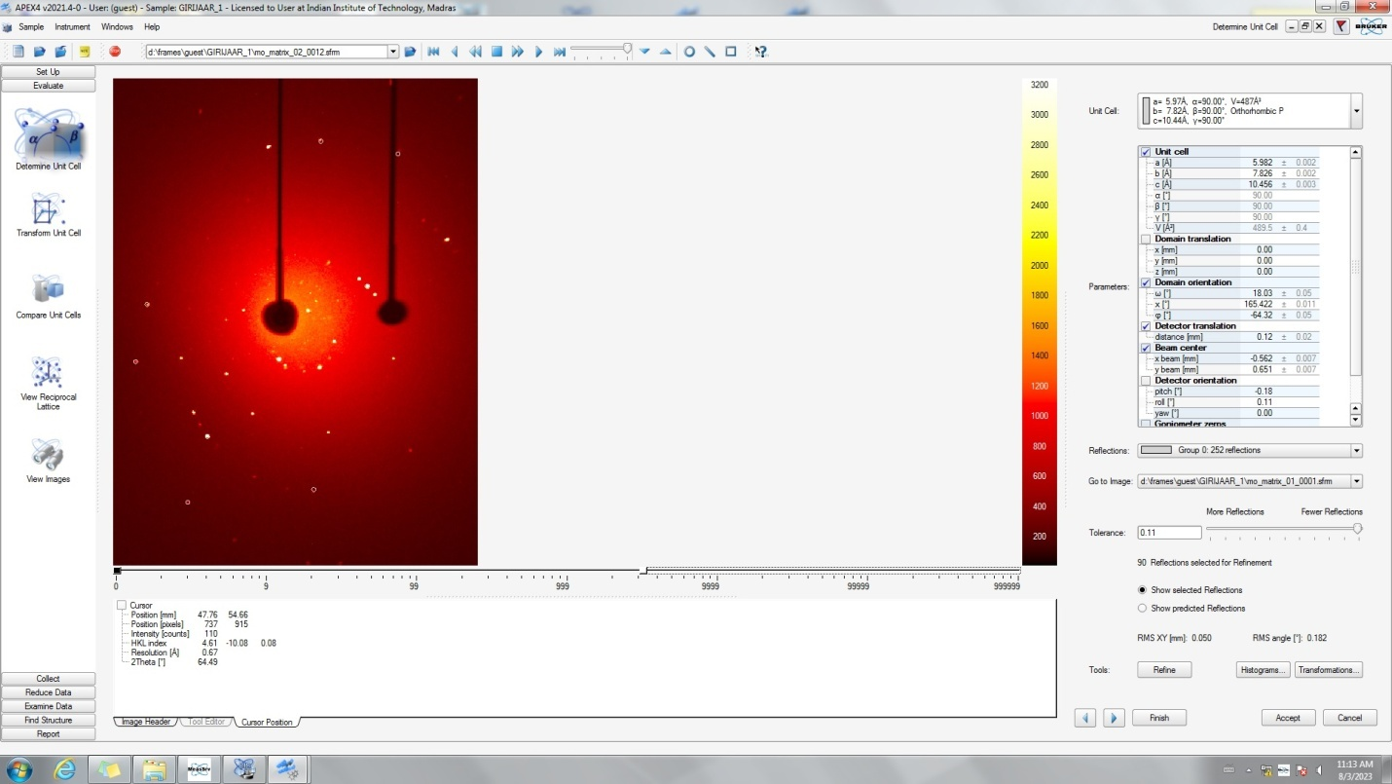
Figure 4,c Cell parameter values of L-Alanine rubidium sulphate crystals,

POWDER X-RAY DIFFRACTION:

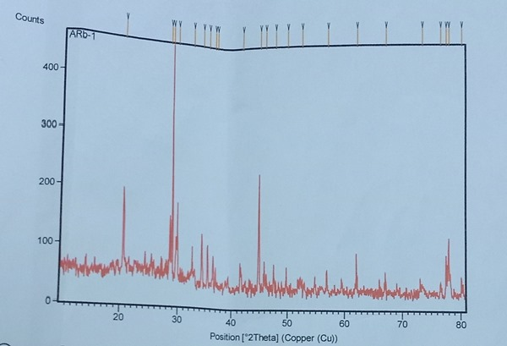

Figure 5 Powder XRD pattern of L-ALANINERUBIDIUMSULPHATE crystal
The powder XRD patterns ofL-Alaninerubidiumsulphate crystals is given in fig 5. The powder X-ray diffraction analysis was performed with a graphite monochromatedCuk_{α} radiation. L-Alaninerubidiumsulphate crystals intensity are higherwhich would be due to the heavy doping of rubidium, strain in the crystal lattice.Thepartical size could be calculated using scherrer equation,Which is 16nm for L-Alaninerubidiumsulphatecrystals
t= K λ/(β cosθ).
Where
t-averaged dimension of crystallities
K- is the scherrer constant,
λ-is the wavelength of x-ray,
θ -peak position measured in radiation,
β-integral breath of reflection (in radian2θ) located at 2θ.

FOURIER TRANSFORM INFRARED SPECTROSCOPY:
FTIR spectra is recorded for L-Alanine rubidium sulphate crystals by using Shimadzu fourier transform Infra red spectroscopy instrument by KBr pellet technique in the range 500 - 4000cm ^{_1} and its spectrum is shown in figure 6. The best way to elucidate the functional group of grown crystal is FTIR analysis. It was interpreted in the wave number range 450-4000cm^{_1}. Figure 6 shows the vibrational spectral frequencies of rubidium doped L-Alanine sulphate crystals. The peak at 3650-3340 cm^{_1} shows the OH stretchingvibrations of the metal salt doped L-Alanine crystals. The absorption band occurring at 3084.18cm^{_1} may be attributed to NH3⁺ asymmetric stretching vibration. The sharp and short bands at 1606.70cm^{_1} and 1514.12cm⁻¹ reveals that there is a weak asymmetric and strong symmetric NH3⁺bonding vibrations. The sharp band at 1413.82cm^{_1}owe’s to coo⁻symmetric stretching.CH2 twisting and COO⁻ wagging are ascribed in the range 1359.82cm⁻¹ and 617.22cm⁻¹ . The C-C stretching is imputed at 1022.27cm⁻¹
The sharp peak noticed at 1112.93cm⁻¹ is due to NH₂ and NH₃ rocking. The short peak at 2110.12cm⁻¹ is due to NH3⁺ asymmetric deformation and NH3⁺ hindered rotation. Also the addition of rubidium metal salt do not show any significant crystal spectrum, a strong peak at 2603.9012cm⁻¹ reveals the presence of amine group for doped metal crystal. Thus there is a significant identification of the functional group amine doped with the metal crystal.
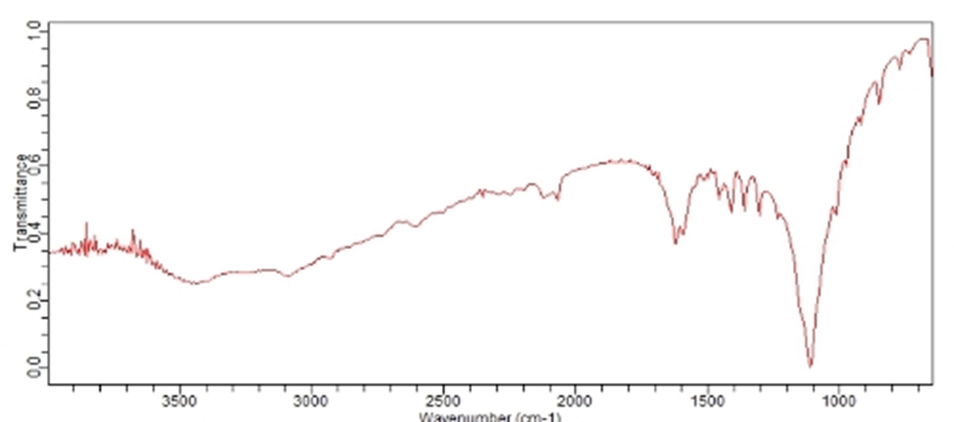
Figure 6 Infra red spectroscopy of rubidium doped L-Alanine sulphate crystals

ULTRA VIOLET-VISIBLE-NIR SPECTROSCOPY :
The energy band structure, effect of impurity, excitons, localized defects and vibration of lattice can be studied with the aid of optical properties. The transmittance nature of the doped crystal is exposed in Figure 7. The metal, Rb doped L-Alanine shows nearly 80% of transmittance and also pronounced 8% higher transmission than the pure L-Alanine. Due to lesser dislocation density contributes to the reduction of scattering centres of crystal, the transmission behavior of Rb doped L-Alanine crystal was increased. These lead to the sample enroute for the fabrication of UV tuneable laser device components. The energy dependency of the absorption coefficient(alpha) in the high energy region indicates the presence of a direct band gap that complies with the highest photon energy . The band gap energy can be calculated by the equation as follows, E_{g}= hC/λ_{max,} Where h- plank’s constant, C- velocity of light, Eg- 4.41 x10⁻¹⁹ ,λ_{max}– maximum wavelength. The calculated band gap energy of L-Alanine crystal is 4.3eV. The loss of electromagnetic radiation , is caused due to scattering and absorption in the crystal is specified by its extinction coefficient value. Using the equation K=λα/4π extinction coefficient was calculated and there is a decrease in the coefficient value for rubidium doped L-Alanine crystal. Thus we can say that these crystal plays a vital role in the optoelectronic applications.

The absorbance and reflectance graph of L-Alanine rubidium sulphate crystal is shown in figure 7a and 7b where their absorbance and reflectance are in higher wavelength also with maximum reflectance. The lower cut-off wavelength of pure and doped crystals occurs at 246nm and 235nm, respectively. Thus it is clear that both of materials possess very good optical transparency up to 1500nm. The doped crystal has better transparency window compared to the pure one. The property makes the material suitable for the many potential and nonlinear applications.

Figure 7a UV-VISIBLE Graph of L-ALANINERUBIDIUM SULPHATE CRYSTALS

Figure 7b UV-VISIBLE Graph of L-ALANINERUBIDIUM SULPHATE CRYSTALS

TGDTA ANALYSIS
The informations regarding phase transition, water of crystallization and different stages of decomposition of the crystal system is studied in TG DTA.Thethermal analysis is of L-Alanine rubidium sulphate crystal is shown in figure 8. In TGA for L-Alanine rubidium sulphate crystal specimen there is no weight loss around 240◦c indicating no inclusion of water in the crystal lattice,which is used as a solvent for crystallization, major weight loss starts around 270⁰C, showing the decomposition point of the crystal synthesized. However, above this temperature there is a slight weight loss taking place. In DTA the strong endothermic peak located around 285⁰C Shows good crystallinity of the doped specimen.

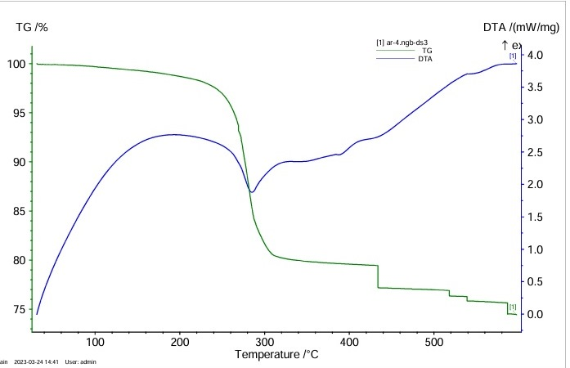
Figure 8 TGDTA graph of L-ALANINERUBIDIUMSULPHATE Crystal

CONCLUSION:
Rubidium sulphate is doped with L-Alanine to obtain L-Alanine rubidium sulphate crystal-Bulkiest transparent single crystal by slow evaporation solution growth technique (SEST).The so formed crystals is characterized by various technique like single crystal XRD, Fourier Transform Infra red spectroscopy (FTIR), UV-visible spectroscopy , Thermogram –Differential Thermal analysis (TG-DTA)and also simultaneous. Thermal analysis (STA, powder XRD, Scanning Electron Microscopy -Energy dispersive spectroscopy (SEM-EDS).The single crystal XRD analysis concludes that there is a slight different in cell parameter values of doped L-Alanine with system monoclinic than the pure L-Alanine with orthorhombic system showing that these is change in structure than the pure L-Alanine, The powder XRD. Shows a slight variation in intensity and shift in diffraction peaks of doped L-Alanine rubidium sulphate crystal. These is also a scanty shift variation in te wavenumber of functional groups noted from FTIR of pure L-Alanine than the doped L-Alanine rubidium sulphate crystal. The optical behaviour (UV- Visible ) of L-Alanine rubidium sulphate crystal is enhanced due to the doping of rubidium in the form of rubidium sulphate to L-Alanine and its band gap energy is also higher than the pure L-Alanine, which make it to apply for photonics. SEM analysis shows that there is a slight modification in the surface morphology of L-Alanine rubidium sulphate crystals and the EDS spectrum shows the presence of rubidium in L-Alanine rubidium sulphate crystals. The second harmonic generation value shows that those is a slight increase in value than pure one indicating the higher Nonlinear optical efficiency of L-Alanine rubidium sulphate crystal. The thermal analysis concludes that so formed L-Alanine rubidium sulphate crystal has got the tendency to withstand a very high temperature and have higher melting point .
REFERENCES
1.K. Meera et al., J. Cryst. Growth ,2004.
2.K. Kirubavathi et al., Spectrochim. Acta Part A, 2008.
3.S.B. Monaco et al., J. Cryst. Growth, 1987.

4.C. Justin Raj et al., Opt. Commun., 2008.

5.L. Misoguti et al., Opt. Mater., 1996.

6.W.S. Wang et al., J. Cryst. Growth, 1999.

7.S. Chenthamarai et al., Mater. Chem. Phys., 2000.

8.Thenneti Raghavalu et al., J. Cryst. Growth, 2007.

9.R.Mohan Kumar et al.,J. Cryst. Growth, 2005.

10.A. Aravindan et al., Spectrochim. Acta Part A, 2008.

11.V. Krishnakumar et al., Spectrochim. Acta Part A, 2006.

12.C.Ramachandra Raja et al., Mater. Lett.,2009.

13.K. Sangwal et al., Prog. Cryst. Growth Charact.,1996.

14.C. Krishnan et al., J. Cryst. Growth, 2008.

15.S. Goma et al., Mater. Lett.,2006.

16.S. Balamurugan et al., Mater. Chem. Phys.,2009.

17.J. Podder, J. Cryst. Growth, 2002.

18.K. Meera et al., J. Cryst. Growth,2005.

19.T. Balakrishnan et al., Mater. Lett.,2008.

20.C.Balarew et al.J.Solid State Chem.(1984)
21.C.Krishnan et al.PJ.Cryst.Growth(2008)
22.C.Ramachandra Raja et al.Prog.Cryst.GrowthCharact.(2009)

